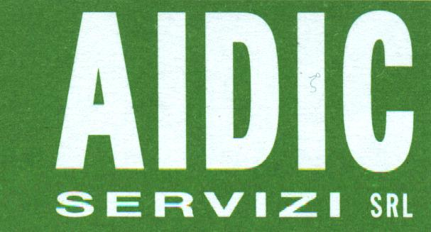

Via Giuseppe Colombo, 81/A
I-20133 Milano, Italy

TRANSFER OF COPYRIGHT AGREEMENT

Authors:
__________________________________________________________________________________________
__________________________________________________________________________________________
__________________________________________________________________________________________

Title of Paper:
__________________________________________________________________________________________
__________________________________________________________________________________________
__________________________________________________________________________________________

Full name ,address, phones and e-mail of author who undersigns this Agreement.

Author's name______________________________________________________________________________

Address____________________________________________________________________________________
__________________________________________________________________________________________
_________________________________________________________________________________________

Voice Phone :______________________________

Fax Phone :______________________________

e-mail :______________________________

Statements:

1. The Undersigned, desiring to publish the above paper in the publication
Chemical Engineering Transaction, Vol. 29, 2012 – PRES2012 (15th Conference Process Integration, Modelling and Optimisation for Energy Saving and Pollution Reduction) by AIDIC Servizi S.r.l.
hereby transfers the copyright in the above paper to AIDIC Servizi S.r.l..
2. The Undersigned retains the following rights in the paper:
a) All proprietary rights over than copyright, such as patent rights.
b) The right to reproduce, have reproduced, revise, adapt, prepare derivative works, present orally or
distribute the above paper for such purpose as teaching (including multiple copies for classroom use),
scholarship or research.
3. The Undersigned warrants that the manuscript is the author's original work. If the work was prepared jointly,
the undersigned agrees to inform co-authors of the terms of this agreement. The Undersigned further warrants
that the work has not been published before. The Undersigned also warrants that the manuscript contains no
libellous or unlawful statements, and does not infringe on the right of others.
4. This Agreement is in act if the above quoted Paper will be accepted for the publication on Chemical Engineering Transaction, Vol. 29, 2012 – PRES2012

Authorised Signature :___________________________

Date :___________________________
For AIDIC Servizi use only
Manuscript no:
Received :

